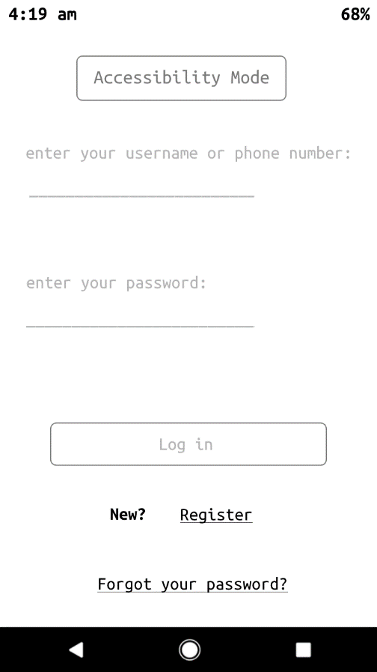

Log-in

Uses account methods to sign in

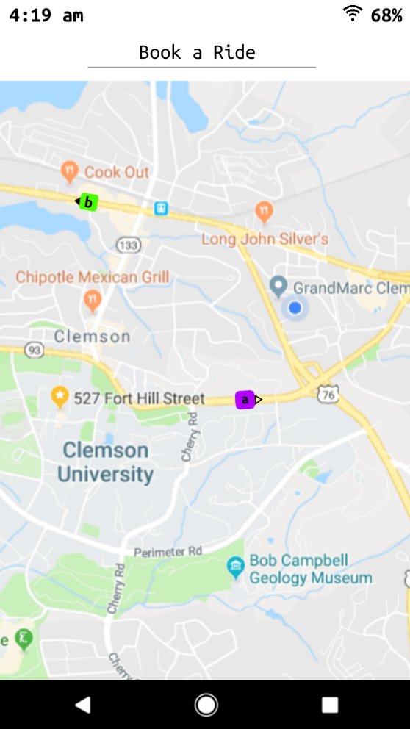

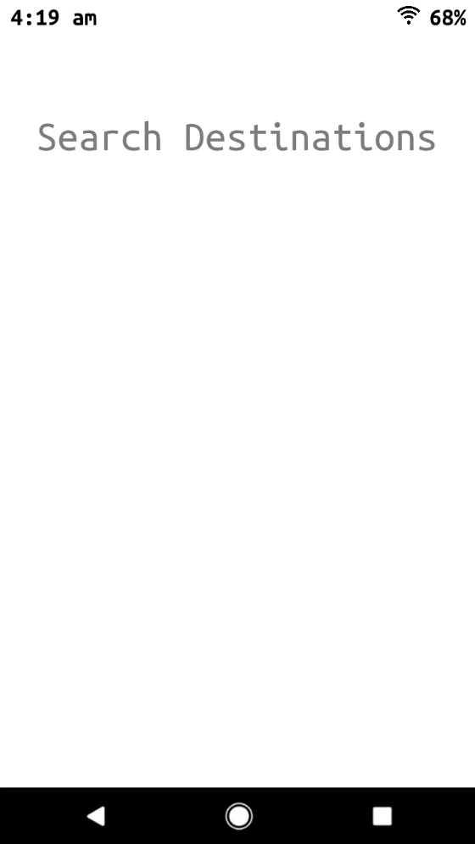

Book-a-ride

Book-a-ride page  
uses same methods as management system

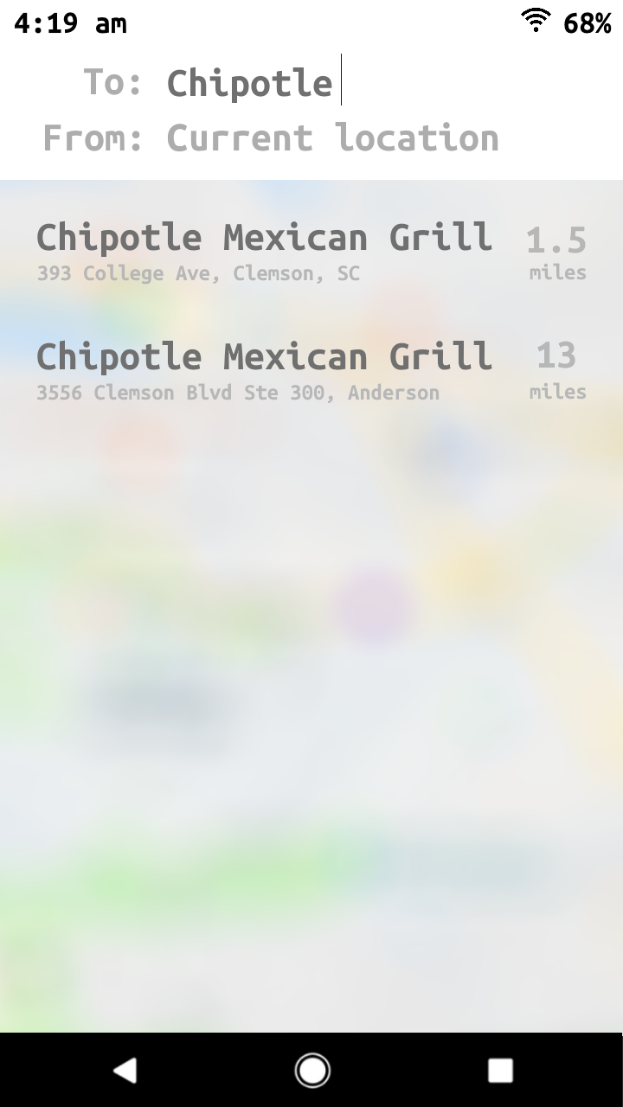

Drop-down menu of possible destinations

setStrtDest()  
setendDest()

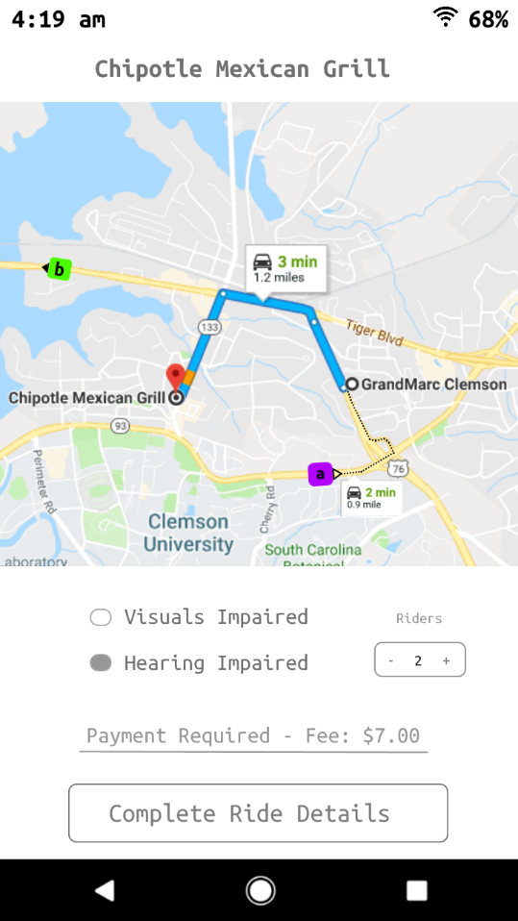

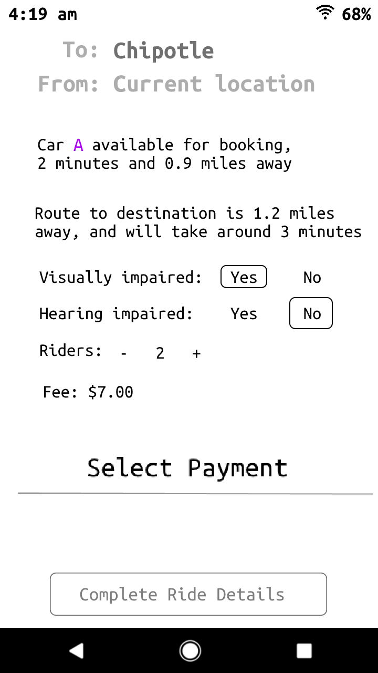

Booking settings

estimateArrival()  
estimateCost()

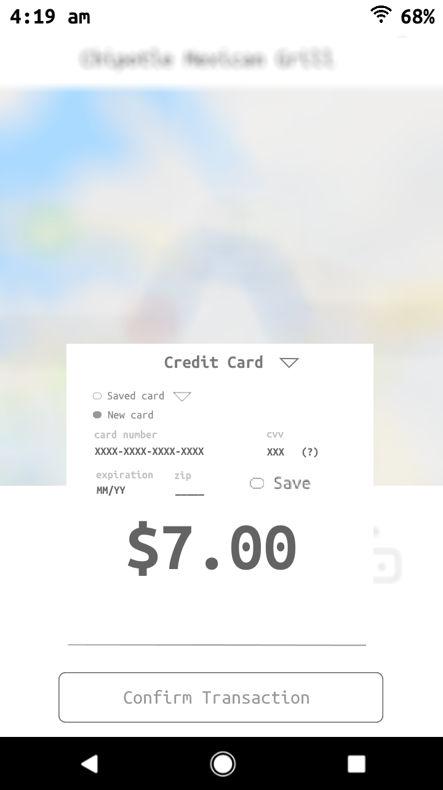

Payment options and confirmation

Payment page  
estimateCost()

bookRide(account)

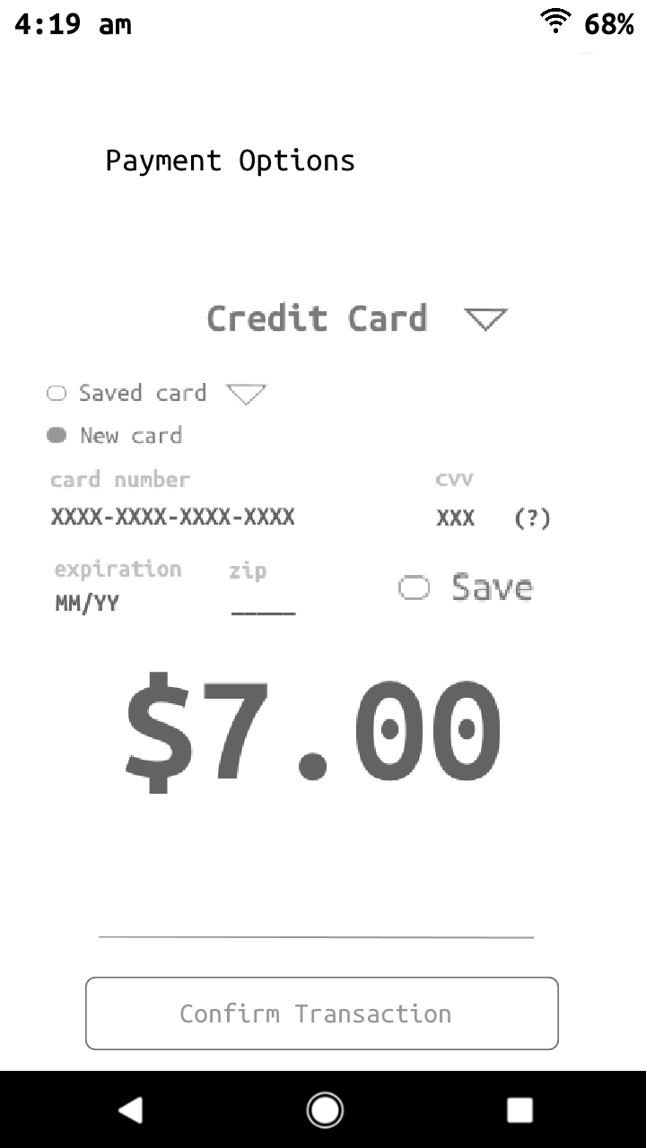

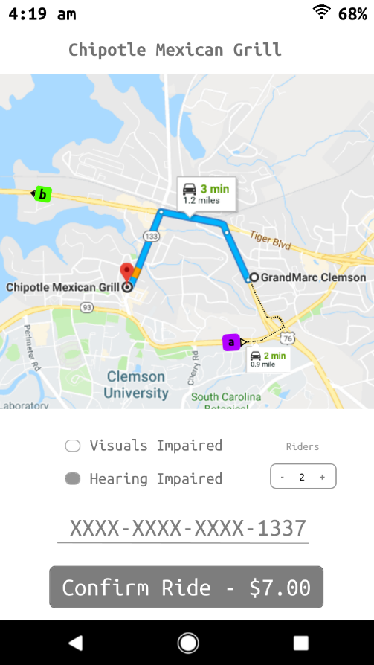

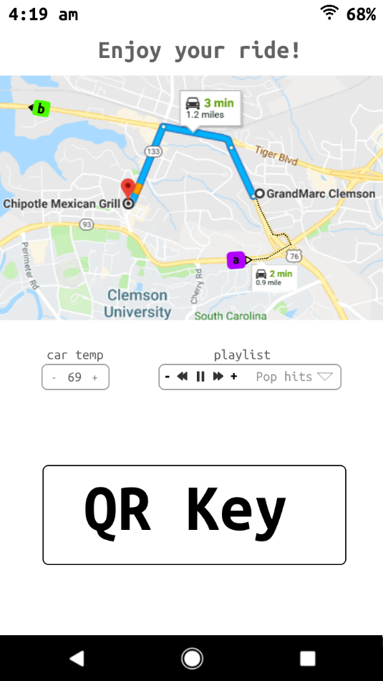

Post-booking settings and QR key menu

ChangeRideSettings()

setTemp(), getTemp()  
setMusic(), setTemp()

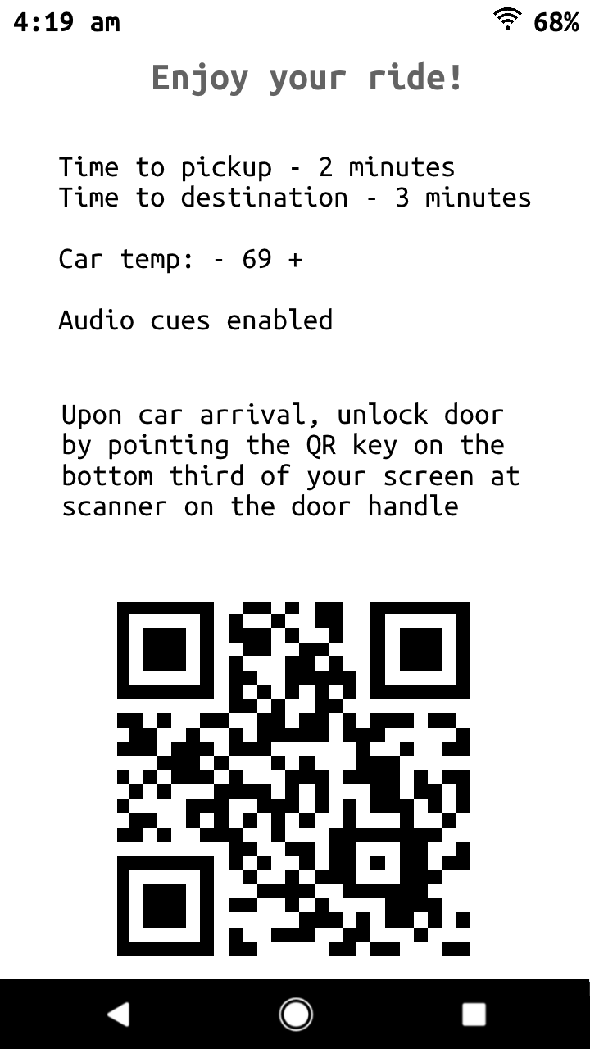

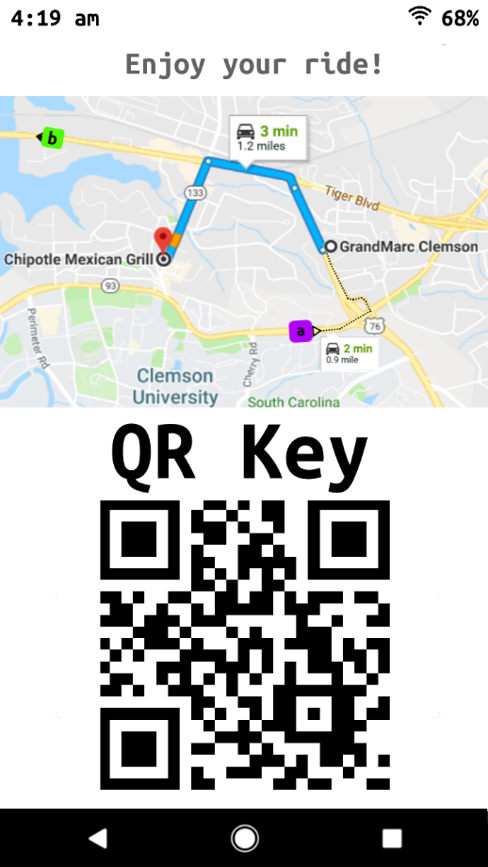

This design matches the requirements by:

* Having users sign in with their credentials
* Having accessibility settings for visually and hearing impaired
* Having riders book their ride by prompting destination
* Having user pay for ride and requesting nearest vehicle from data base
* Having users control vehicle temperature and audio